**Learning Journal**

10/11/2020

I was shown how to create a repository for Unity and GitHub.

12/11/2020

I began checking what Ideas I want to make for this tutorials and coding project.

13/11/2020

I watched tutorials and read up guides on how to do what I wanted to do. So, I began with basic movement scripts for myself to make it so that I have a base to start with.

14/11/2020

When I started moving on to the more complex part for my project, I kept on getting issues that were colliding with the movement code. I was looking at ways to help myself fix these issues and asked for help from lecturers.

16/11/2020

I finally got around making the gain health script with an object to represent a Health Pack and making one to deal damage to the player.

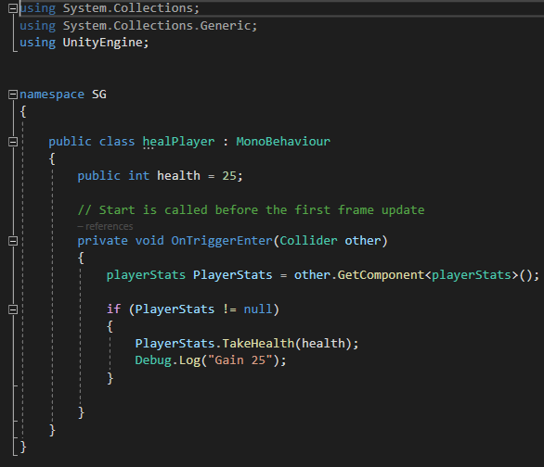

HEAL PLAYER

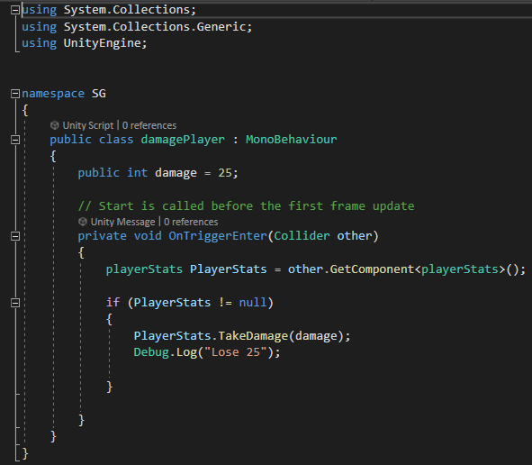

DAMAGE PLAYER

18/11/2020

Here I began to start creating the asset for the health bar, this is to display how much health is taken from the player and if the player is gaining any health.

20/11/2020

I then brought that over to Unity and began to make the code for it. This was a tough process. I first managed to get it so that it shows up in unity and unity but was struggling to make the health go down when touching the health pack. It would stay still and not move.

23/11/2020

I decided to make a health script for the player first instead of dealing with the health bar.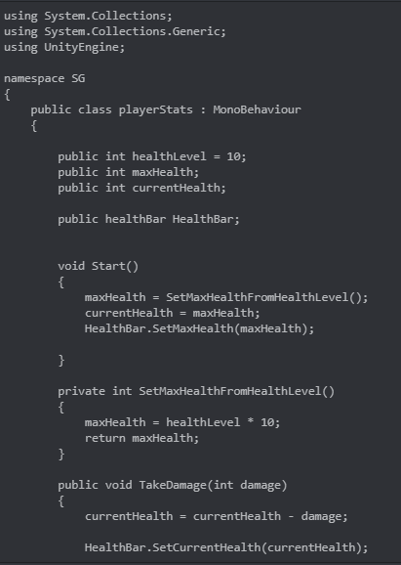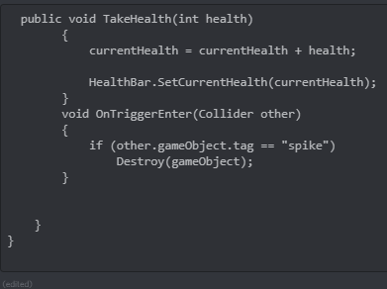

25/11/2020

I then went back to my health bar to get it working and now I have a health bar that takes damage and gains health whenever going over the correct object.

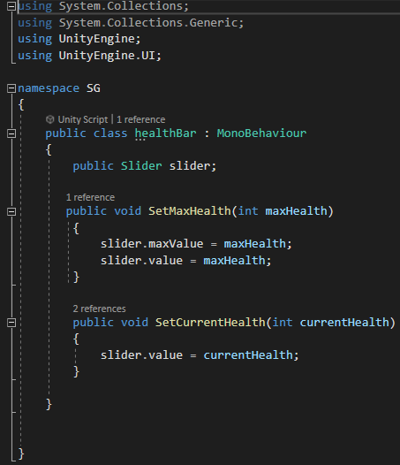

26/11/2020

Finally, I decided to add in a trap to get all the health away and to see if it does work with more and higher damage. This spike was included in the screenshots I took on the 23rd.